MIT School of Engineering
Department of Computer Science and Engineering

Project Synopsis

Group ID : TY-11 AIA - 5
Project Title : Developing an Algorithm for Air Quality Visualizer and Forecast App to Generate Granular, Real-time, and Predictive Air Quality Information
Group Members : Advait Nagar, Payal Gavhane, Rohak Thakur

Enrollment Number | Roll No. | Name of student | Email Id | Contact Number
ADT23SOCB0084 | 03 | Advait Nagar | findadvait@gmail.com | 9454686133
ADT23SOCB0718 | 29 | Payal Gavhane | payalgavhane2005@gmail.com | 9049504907
ADT23SOCB0861 | 37 | Rohak Thakur | rohakthakur0531@gmail.com | 88665 60764

Detailed Problem Statement:
Developing an Algorithm for Air Quality Visualizer and Forecast App to Generate Granular, Real-time, and Predictive Air Quality Information.
In the absence of street-level monitoring, air quality data is typically derived from distant government stations or satellite sources, which fail to capture localized variations caused by traffic, industrial activity, crop burning, and weather conditions. For regions like college campuses and their surrounding communities.

Abstract:

Air pollution has become one of the most critical environmental and health challenges globally. Existing Air Quality Index (AQI) applications and monitoring systems primarily focus on metropolitan regions with well-established monitoring infrastructure. However, small towns, rural areas, and educational campuses often lack ground-level air quality monitoring. This creates a significant data gap that prevents residents, students, and decision-makers from accessing hyperlocal and actionable air quality insights.

Literature Survey: Detail survey done

Air quality monitoring at regional or national scales relies primarily on sparse government stations and satellite retrievals, which are insufficient to capture street-level variations caused by traffic, industries, crop burning, and local weather. Studies show that this lack of spatial resolution leads to significant exposure misclassification for communities, especially in dense or mixed-use areas. While satellite data provide wide coverage, their accuracy at neighborhood scale is limited by atmospheric and surface factors, making them inadequate for campus-scale decision-making.
Recent work highlights the role of low-cost sensor networks as a feasible solution for hyperlocal monitoring. When calibrated and properly maintained, these sensors can map fine-scale air quality gradients and provide communities with real-time information. Complementary approaches such as mobile monitoring (using instrumented vehicles or bicycles) have demonstrated the ability to detect sharp block-by-block pollution hotspots, particularly near major roads and industrial zones.
To convert such heterogeneous data into actionable intelligence, researchers increasingly use machine learning and data fusion techniques. By combining land-use, traffic, and meteorological features with data from regulatory stations, satellites, and local sensors, these models generate real-time maps and short-term forecasts at the neighborhood level. This integration is particularly valuable for environments like college campuses, where localized exposure information can inform outdoor activities, health advisories, and micro-policy interventions (e.g., traffic control, green buffers).

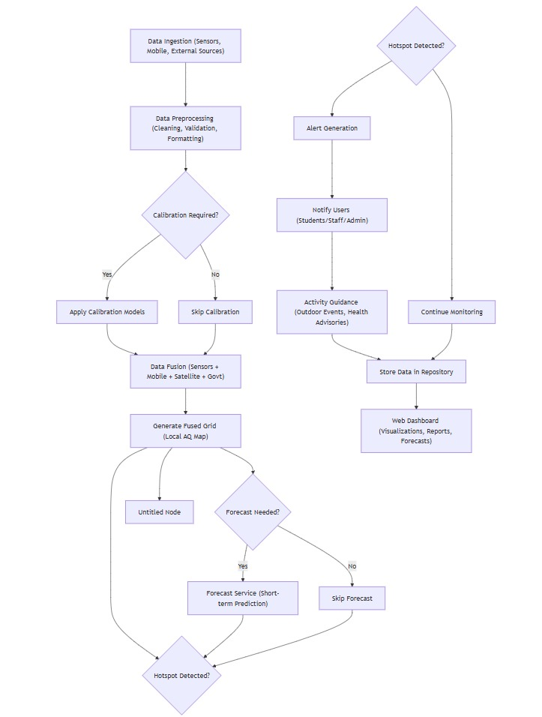
Proposed System (Block Diagram):

